Neo. `Brazil' by Rob Smythe in Bromeliaceae 41(4): 36-42. 2007
Neo. 'Brazil' or should that be Neo. 'Fairchild' or maybe Neo. ‘Braz-el’.
Introduction
There is an ever-increasing number of very large neoregelias that really need sorting out. The spectrum probably starts with the green N. johannis at one extreme, through N. ‘Red Macaw’, then the various spotted N. johannis plants then to N. ‘DeRolf’, then to N. ‘DeRolf’ (with no stripes), Neo. ‘Fairchild’, ‘N Braz-el’ (see later) through to N. correia - araujoi at the other end of the spectrum. probably some where eons in the past, N. marmorata, N. cruenta and N. johannis got together to form hybrid swarms.
These swarms may have been stabilized by selective pollination. The bird with the right size beak may have been the factor. Things like nearly doubling of flower size and formation of a prickle at the end of the sepal (both found here) might restrict those birds with the smaller beak to smaller flowers. Darwin was laughed at when he suggested that a moth would be found with the 30 cm long tongue (proboscis actually). This would be necessary to pollinate an Angraecium sesquipedale it having a 30 cm nectary. Such a moth Xonthopan morganii was subsequently found. Darwin actually went to his grave believing such a moth would be found.
Bromeliad scholars in earlier times thought N. correia-araujoi was derived from N. cruenta and N. marmorata. Today it is more popularly thought that N. johannis is a better candidate than N. cruenta. The reasoning is that N. cruenta occurs to the north of Rio De Janeiro while the other two are found to the south. What was the case eons back? Fossil evidence is virtually unknown for bromeliads. N. cruenta holds its leaves erect. On a N. johannis they rise and curve down earth wise as they lengthen. N. correia - araujoi does the former. Another item of support is the variance in growth pattern of N. cruenta. You would never believe that the extremely large broad green leaved floppy plant growing in shade could turn into a much smaller tightly rosetted, strongly erect red leaved plant when grown in full sun. No wonder the botanists kept refinding it and giving it different names. I don't think we are ever going to sort out the mystery presented above.
The paper below is not that technical but one can easily get lost because I myself thought I had photographed two differently named plants at different times but the blemishes on the leaves proved they were photos of the same plant. Photos 3 & 4 have captions followed by question marks. I can delete from further discussion N. ‘DeRolf' and N. `Red Macaw' as these are now registered clones and with registered clones we don't have to register parentage. I don't think either are wild collected.
Registered Clones (cultivars)
My old friend known to brom growers world wide as Uncle Derek has asked me to write this article. Why have you done this to me Derek? All I asked of him was, could I give the plant, depicted in Shane Zaghini's first book, on page 8, a proper name? We all know this monster of a plant with Grace Goode's pixie like hand caressing the outer leaves. It is called `Brazel Species' in this book. I thought it would be simple to correct the typo but, no, this was not possible as the name Brazil was taken. So I have asked Derek to name it N. `Braz-el' which keeps the incorrect spelling but splits it so we don't offend the Brazilians. All looked well, but, I made enquiries about it in Brom Watch which 1 publish monthly. Should be doing it now instead of writing this!
Continuing on, Ian Hook, Richard Harper, Sam Mammino and of course Derek Butcher have been in contact with me. Ian has sent the news further through his contacts. Two photos of a plant called N. `Brazil' have crossed my desk. None of these is correctly named as they are not N. carolinae types. How do I know that `Brazil' should look like a Neoregelia carolinae? The Bromeliad Cultivar Register 1998 tells us this was a name used by the Quihots in Florida in the 1970's when they had a fetish with Neoregelia carolinae and saw lots of differences in the plants they had. Alas we only know it by name and not why it was considered to be different to all their other plants called N. carolinae! Now we can easily take photographs of our plants to give us some idea of what they look like. These days you can only register if you have a photo!
So the use of `Brazil' as a eultivar name is not allowed because it had already been used. The photos that I received all looked the same as my N. `Braz-el'. We tried to trace the plants back to their origin. One has traced back to Shane Zaghini. The other two are back to the South East Corner of Queensland. Shane's photo looks like it was taken in Grace's yard before the termites found the shed in the photo. 1 will just have to wait for the other sources to surface.
Then I started looking around. N. correia-araujoi (pg. 35 photo # 5 Vinzant) looks similar to N. `Braz-el' (pg. 37 photo #1 Smythe) except you can drive a truck between the leaves of our Townsville N. correia-araujoi. The whorl angle, angle between successive leaves, is so close to 180 degrees that with some of them the leaves nearly pack in three columns. The plants of N. correia-araujoi I have take 4 to 5 whorls of leaves before the gaps between the original leaves are filled. The plant that I refer to as N. `Braz-el' has beautiful shape and wide leaves. This nearly fills the gap in two whorls but takes no more than three to do the job. Because of its shape I thought I could discard N. correia- araujoi as a name for my plant even though its markings are closest to that of N. `Braz-el'. The other contestants would be N. `Fairchild' and a widely spread unregistered plant known to me as N. cruenta `French's Clone'. I suppose it is difficult to register the latter as it is not a cruenta and most likely is a cruenta hybrid with N. concentrica or even more likely N. johannis. N. `Fairchild' has been down this path. Firstly it was named as a cruenta then as a johannis and now has its own clonal name. That's another story. I got my measuring tools out and all I could exclude was the `French's Clone' as it had much thicker leaves. With the others 1 measured thickness as well as width to length ratios and could not develop additional data which would clearly separate them. Whorl angle is not a valid tool as it is culture dependent but reliable enough in these extreme cases. It is virtually impossible to work at the scientific level with plants coming from the horticultural industry.
I found out that Harry Luther has said that N correia-araujoi is believed to be a natural hybrid. This could easily be checked by genninating wild collected seed. Could I do a major diversion here for the serious breeders of bromeliad species?
Using wild collected seed is not the same as selfing wild collected plants unless you take precautions. I have found that out in my area where ants are the major problem. Ant outcrossing has occurred from plants up to 4 metres away. A friend who has less of the large aechmeas to distract our local humming bird's relative (Nectarinia jugularis), has found out that the outcrossing can be from anywhere. This wrecks any conclusions you might make about the genetics of the so called species or natural hybrid. The serious student, when selfing a plant, should move plant/s indoors before any flowers open and cover the flower head/s with a stocking. Clearly mark crossed flower or remove unwanted flowers. This is the only way that you have any hope of finding out if you have a true species. I'm not sure all the species photos found in ‘fcbs.org’ would meet these criteria but we can only do our best. I am sure Derek would love to have photos of wild collected plants and details of seedlings, from wild collected seed, of the plants suggested to be natural hybrids.
So where are my investigations at? To register this N. `Braz-el', it would have to be different to N. johannis and different to N. `Fairchild', for a starter so it is time to look at the evidence. Here I will borrow some pictures from the fcbs site with Derek's permission of course.
My plant in question. A young one at that is yet to mottle.
Well that looks good. My plant of `Fairchild' (pg. 39 photo # 3 Smythe) looks just like the plant of `Fairchild' found on the FCBS site (pg. 37 photo # 2 Johnson) and my plant of N. `Braz-el' (pg 37 photo # 1) looks nothing like either of the N. `Fairchild' photos and it does not look like any of the FCBS photos of N. johannis.
"Right! So Rob should go ahead and name it N. Braz-el".
"Wrong ! I only wish it was that easy?
"Heh Rob! What are you doing? That is another photo of N. `Braz-el'. You covered it with your first photo, its not `Fairchild"'.
Look more deeply my friends while Uncle Derek pulls his hair out. You will see why the `?' marks were put against the `Fairchild' photos. See in this latter photo that there is a little heart shaped mark at the end of the leaf at about 3.30 and the little burn at the tip at about 11 o'clock.. Yes there they are again in the next photo up at about 2.30 and 9 o'clock. They are photos of the same plant at different ages. So as every second person has been telling me N. `Braz-el' and N. `Fairchild' look a lot alike. In fact they are probably the same clone. This plant grows erect like cruenta and flattens with age becoming more johannis like. I was fooled. I have photographed the same plant twice. Once, as a younger plant, it is the same as another plant of `Braz-el' and photographed it about a year later and it is the same as `Fairchild'.
"Well Rob, at least you eliminated N. correia-araujoi with its very open conformation "
"Wrong again!"
Look at the photo from FCBS web site (see pg.35 photo # 2 Johnson).
Could one of these be our plant N. `Braz-el' grown hard and with little fertilizer? While this may be the case, it does seem that the plants Lisa Vinzant obtained in the 1980's were smaller than we expect when looking at the dimensions in the prologue
Maybe N. `Braz-el' = N. correia-araujoi (Vinzant) and maybe they are all the same clone as N. `Fairchild' and thus Neoregelia johannis. You will have to wait now till flowering time so that I can at least confirm that they may or may not be all the same species (hybrid).
When I first received my N. correia-araujoi it was a plain, green, strappy thing which I planned to discard. I planted a pup in the sun and all the mottling turned up. How nice. Looking back now and with the photos above could the only difference between N. johannis and N correia-araujoi be where it is grown?
N. johannis was described from plants in a heavily shaded area near the sea while N correia-araujoi came from a presumably more open valley (Mambuco River Valley). They were both said to have great variations. Something for the botanists to consider. My plants are not wild collected and for what they are worth they have quite different dispositions of the leaves. May I be so bold as to suggest that they could all be one taxon. That is the lumper's point of view but as a splitter they become three. The sparsely narrow leaved flattened type; the multi- narrow leaved type and the broad leaved type like N. `Braz-el', N. `Fairchild', Vinzant's plants and maybe even N. ‘DeRolf'.
So after all that, what do I do? The simplest thing would be to drop `Braz-el' after all my work and call it `Fairchild'. What can you do? If you have both please grow them side by side in a couple of locations and let me know your findings.
N `DeRolf'-If you get a non variegated form does it grow stronger and more erect or does it flop at the tips like its mother. Please let me know.
The saga continues but shows that non-attention to detail in the early stages compounds problems at a later date. Thanks to Derek for doing some fill-in information. Hopefully a couple of related articles from Derek will accompany this publication. They should help the more serious scholars to follow my line of thought.
I think, just for the sake of tidying up a mess in our bushouses, all the plants out there carrying the name N. `Brazil' and (I think they will all fit with N. `Braz-el') should be renamed N. `Braz-el'. For this reason alone I would suggest registration is needed. It can be linked with N. `Fairchild'. With further research we may, like my pair of plants, find they are the same. If my finding is a general one, we won't be the first to name the same plant twice.

Neoregelia Brazil

My dear friend known to brom growers world wide has asked me to write this article. Why have you done this to me Derek? All I asked of him was, could I give the plant, depicted in Shane Zaghini’s first book, on page 8, a proper name. We all know this monster of a plant with Grace Goode’s pixie like hand caressing the outer leaves. It is called ‘Brazel Species’ in this book. I thought it would be simple to correct the typo but no not possible as the name Brazil was taken. So I have asked to name it Neo. Braz-el which keeps the incorrect spelling but splits it so we don’t offend the Brazilians. All looks well but, I made enquiries about it in Brom Watch which I publish monthly. Should be doing it now instead of writing this.

Continuing on, Ian Hook, Richard Harper, Sam Mammino and of course Derek Butcher have been in contact with me. Ian has sent the news further through his contacts. Two photos of a plant called N. ‘Brazil’ have come into my view. None of these is correctly named as they are not N. carolinae types. How do I know that ‘Brazil’ should look like a Neoregelia carolinae? The Bromeliad Cultivar Register 1998 tells us this was a name used by the Quihots in Florida in the 1970’s when they had a fetish with Neoregelia carolinae and saw lots of differences in the plants they had. Alas we only know it by name and not why it was considered to be different to all their other plants called N. carolinae! These days we can easily take photographs of our plants to give us some idea of what they look like. These days you can only register if you have a photo!
So the use of ‘Brazil’ as a cultivar name is not allowed because it had already been used. The photos all looked the same as mine. We tried to trace them back to their origin. One has traced back to Shane Zaghini. The other two are back to the South East Corner of Queensland. Shane’s photo looks like it was taken in Grace’s yard before the termites found the shed in the photo. I will just have to wait for the other sources to surface.

Now I start looking around. N. correia–araujoi looks similar except you can drive a truck between the leaves of the local ones. The whorl angle, angle between successive leaves, is so close to 180 degrees, so that with some of them the leaves nearly pack in three columns. The plant that I will refer to as N. Braz-el has beautiful shape and wide leaves. I thought I could discard this correia– araujoi name as a possibility though its markings are closest to this plant’s. The other contestants would be N. ‘Fairchild’ and a plant known to my knowledge as N. cruenta ‘French’s Clone’. I suppose it is difficult to register it when it is not a cruenta and most likely is a cruenta hybrid with N. concentrica or N. johannis. N. ‘Fairchild’ has been down this path. Firstly it was named as a cruenta then as a johannis and now has its own clonal name. That’s another story. I got my measuring tools out and all I could exclude was this latter plant as it had much thicker leaves. With the others I measured thickness as well as width to length ratios and could not develop data which would clearly separate them. It is virtually impossible to work at the scientific level with plants coming from the horticultural industry. I found out that Harry Luther has said that N. correia-araujoi is believed to be a natural hybrid. This could easily be checked by germinating wild collected seed. Could I do a major diversion here for the serious breeders of bromeliad species?

Using wild collected seed is not the same as selfing wild collected plants unless you take precautions. I have found in my area where ants are the major problem that out crossing has occurred from plants up to 4 metres away. A friend who has less large Aechmeas to feed our local humming bird relative, the outcrossing can be from anywhere. This wrecks any conclusions you might make about the genetics of the so called species or natural hybrid. The serious student when selfing a plant should move it indoors before any flowers opens, cover flower head with a stocking. Clearly mark crossed flower or remove unwanted flowers. This is the only way that you have any hope of finding out if you have a true species. I’m not sure all the species photos found in fcbs would meet this criteria but we can only do our best. I am sure Derek would love to have photos of wild collected plants and details of seedlings from wild collected seed of the plants suggested to be natural hybrids.

So where are my investigations at? To register this N. ‘Braz-el’, it would have to be different to N. johannis and different to N. ‘Fairchild’ So it is time to look at the evidence. Here I will borrow some pictures from the fcbs site with Derek’s permission of course.

My plant in question. A young one at that.

N. Braz-el RSS
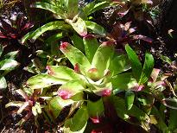

N. ‘Fairchild’ FCBS

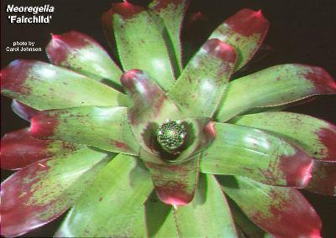

N. ‘Fairchild” RSS

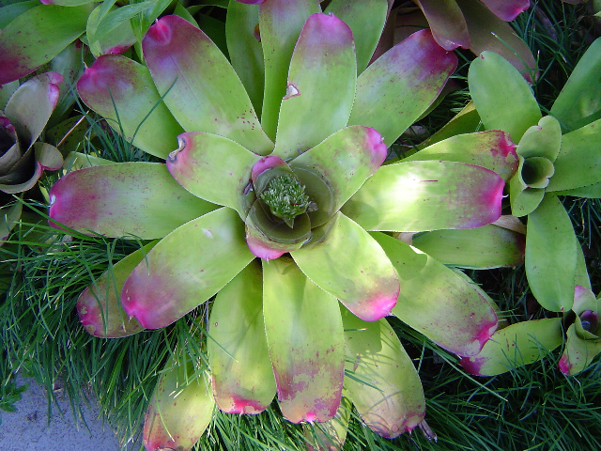

Well that looks good. My plant of ‘Fairchild’ looks just like the plant of ‘Fairchild’ on FCBS and my plant of N. ‘Braz-el’ looks nothing like either of the N. ‘Fairchild’ photos and it does not look like any of the FCBS photos of N. johannis.

Right? So I should go ahead and name it. Wrong !

N. ‘Fairchild’ RSS Photo #2
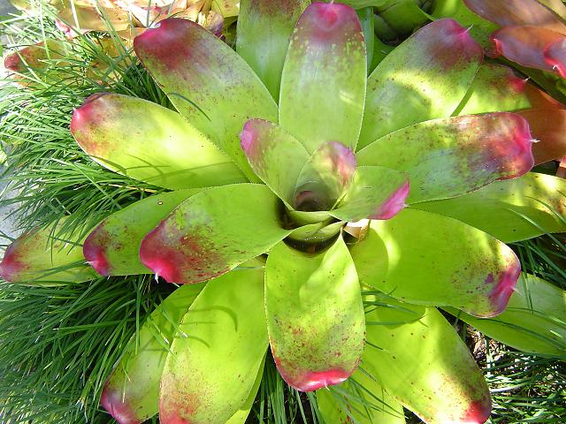

Heh Rob! What are you doing? That is a photo of N. ‘Braz-el’. You covered it with your first photo.

Look more deeply my friends while Uncle Derek pulls his hair out. See the little heart at the end of the leaf at about 3.30 and the little burn at the tip at about 11 oclock.. Yes there they are in the next photo up at about 2.30 and 9 o’clock. They are photos of the same plant at different ages. So as every second person has been telling me N. ‘Braz-el’ and N. ‘Fairchild’ look a lot alike. In fact they are probably the same. Well Rob, at least you eliminated N. corriea –araujoi Wrong again. Look at this photo below from FCBS.

N. corriea araujoi (Vinzant)

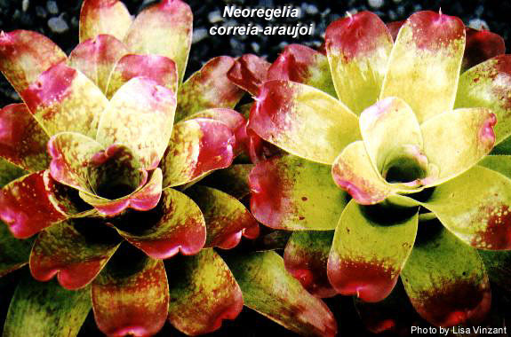

Could one of these be our plant grown hard and with little fertilizer? While this may be the case, it does seem that the plants Lisa Vinzant obtained in the 1980’s were smaller than we expect when looking at the dimensions in the protologue

Maybe N. ‘Braz-el’ = N. correia- araujoi (Vinzant) and maybe they are all the same clone as N. ‘Fairchild’ and thus Neoregelia johannis. You will have to wait now till flowering time so that I can at least confirm that they may or not be all the same species (hybrid).

The saga continues but shows that non-attention to detail in the early stages compounds problems at a later date.

Rob Smythe MSc

